visual design and beyond.

I chose <https://www.lib.uwo.ca/> as the site to critique. The school colour is purple. I hope the site does not use it as an added method to convey information.

This video <https://www.youtube.com/watch?v=xrqdU4cZaLw&feature=youtu.be> is about visual game design but is useful for the information it gives information on visual impairments and designing to accommodate. I found the first 5 minutes useful.

“deuteranomaly, a type of red-green color blindness in which the green cones do not detect enough green and are too sensitive to yellows, oranges, and reds. As a result, greens, yellows, oranges, reds, and browns may appear similar, especially in low light. It can also be difficult to tell the difference between blues and purples, or pinks and grays.”

Visual impairments are difficult to design for since colour perception is based on the number of colour receptor cells in the eye, and this number different for everyone. It can be simulated like in the video. Designers are catching up, Fortnite has one of the best colour deficiency accommodations, I say this because it works, I can adjust the colour slider to make visual indicators visible. I have seen accommodations that turn the image black and white and simply strip the information, nice one Blizzard Entertainment, other systems, Far Cry 5 adjusted the HUD to be visible in a different area obscuring the section that worked previously. I had the choice of which part I could see and which part I couldn’t. These are example of design with specific accommodations that were implemented poorly.

To assess UWO’s library website I will define the criteria to consider.

initial reaction

Initial reaction “gut reaction” of the library website is that it is densely organized.

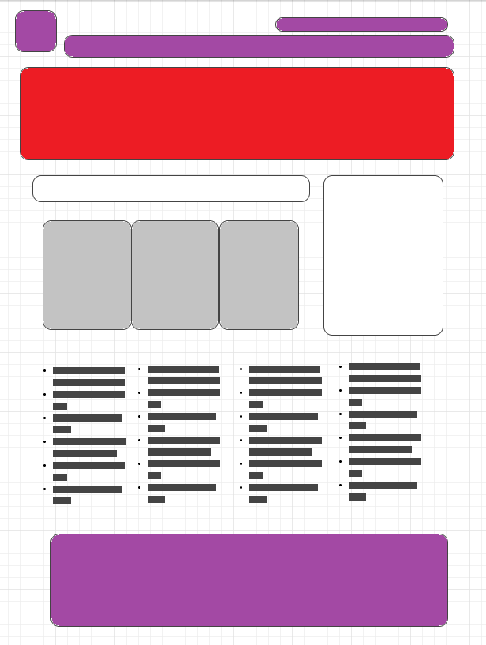

Having enormous amounts of information on the landing page raises the question of how much that information is used and if it would benefit the site to organize the information into a simpler front page. Frequent users of the site would learn to find the information and new users would need to be planned for and guided to the information, but the landing page would be cleaner and still service most users. Header, footer and public relations banner. Main content has distinctive areas, header, public relations image banner

Usability

The UWO’s website is designed in a typical layout most users will be accustomed to using. The arrangement is an intuitive home link and menu. An image marquee that links for more information is practical for events. There is a top right-hand side “Popular Links”, I wonder how many clicks it receives and if there are more links from the main content panel in the middle could be buried 1 click deep to clean out the information over load in the middle. I would only suggest this if after user testing showed that it was a viable option and if the web logs indicated that the user use suggested it was feasible. Given the site arrangement and the non-alphabetical listings I also make the assumption that the arrangement is based on usage, that Research Guides is the most prominently used link in Getting Started.

Accessibility

To critique accessibility I used 2 tools, achecker.ca and site improve browser add-in. I started with tabbing through items and the site is designed to accommodate screen reader and sightless users. Again the amount of links on the landing page is burdensome on screen readers and waiting while it runs through all links to reach the desired link. UWO’s site meets class A accessibility easily. I would suggest meeting AA accessibility standards. This would include colour contrast standards and would make the site accessible to sight impaired individuals with little effort.

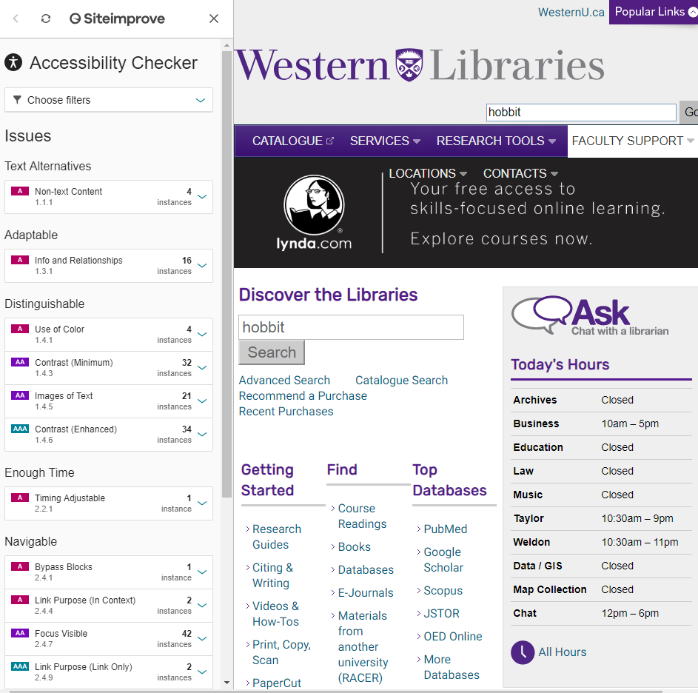

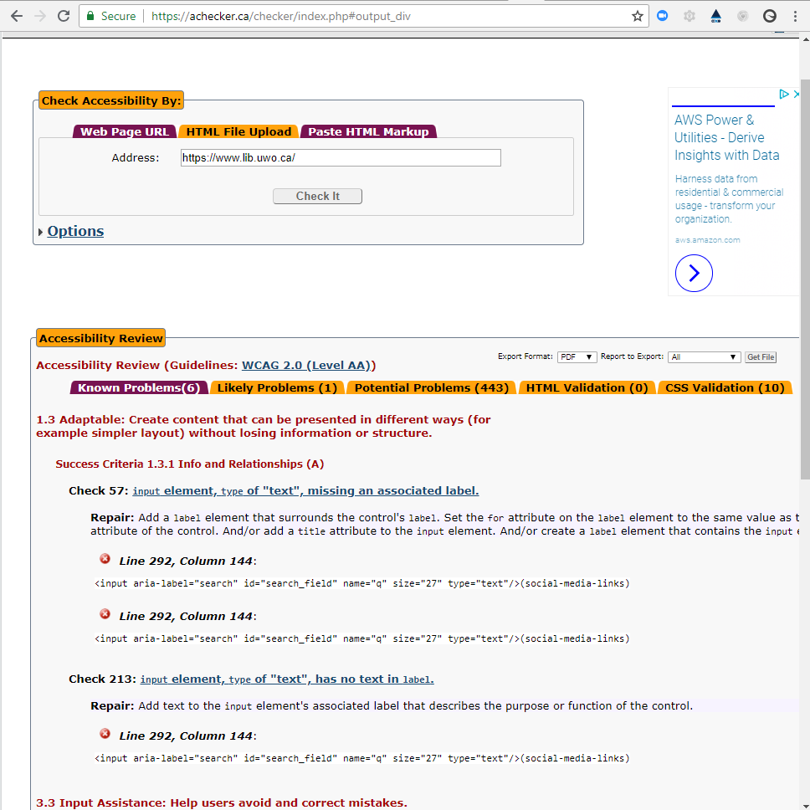

Following "the moving lights", perceiving the entirety before the individual objects.

Requires the design of the website to capture that first impression and lead the user to the material they desire.

Conclusion

The UWO library website meets the information needs of the university. The site arranges the numerous links and information needs in a very organized manner. It could be the benefit of having a library school in their midst. I found no major flaws in functionality of the site, there were a few issues with issues coding issues that should be looked at that may not be issues but could be adjusted to not show up in achecker or site improve. The most constructive suggestion I have would be to assess the usage of the main page, with the use of a heatmap and trim the first level links on the landing page. I would suggest that the target audience be assumed to be first year students and assume any returning users can handle a 1 click to reach their desired information page. This could greatly reduce the amount of information on the landing page and lessen the information overload that many library websites fall victim of.